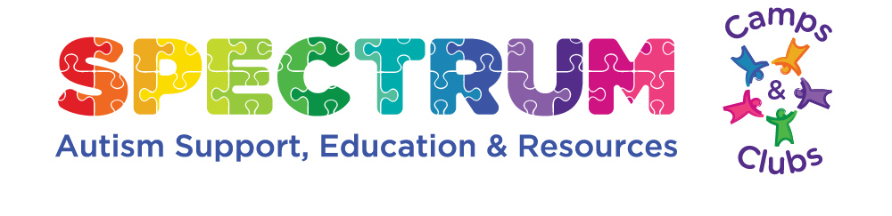
Spectrum Adult Group (Saturday Social Club) Rules
Group Purpose: The purpose of this group is to encourage and foster positive relationships with others so that the members will be able to be more confident and successful in social and other situations and making friends.
Note that social club doors open at 6:30 pm.
Requirements:
1.Members will sign in and out at each meeting in Check-in log provided onsite.
2.Members will ensure pick-up by 8:30 pm as meeting ends promptly at 8:30 pm.
3.Members will make an effort to be friendly and open to others.
4.Members will voice their opinions, comments or concerns to a group leader at appropriate times.
5.Members will bring refreshments to share or money for activities as needed.
6.Members will be willing to try new things for the benefit of the group.
7.Members will not use cell phones/other devices during a meeting unless it is an emergency.
8.Members will not use foul or inappropriate language.
9.No alcohol will be consumed during group activities by members.
10.No self-injurious behavior, destructive behavior, threatening behavior or aggressive physical behavior will be tolerated.
11.Group leaders have the right to ask any member to refrain from attending if in the best interest of the group or policies are not followed

